1.

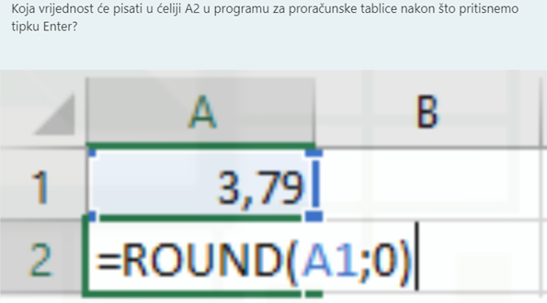

|  |  |
| --- | --- |
| **Odgovor:** |  |

2.

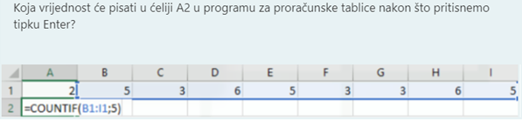

|  |  |
| --- | --- |
| **Odgovor:** |  |

3.

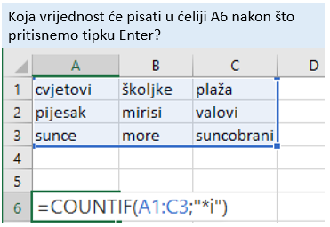

|  |  |
| --- | --- |
| **Odgovor:** |  |

4.

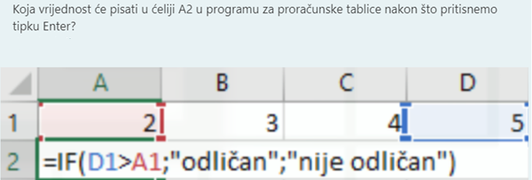

|  |  |
| --- | --- |
| **Odgovor:** |  |

5.

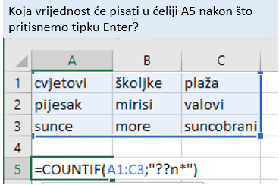

|  |  |
| --- | --- |
| **Odgovor:** |  |