UNIT 4: EVERY DAY
LESSON 2: MY FAVOURITE PART OF THE DAY

1 Pogledajte video i napravite sve zadatke iz videa
https://drive.google.com/file/d/1fw4aUx3Y6c3Y7372fqheNk_XQTMW14Oa/view?usp=sharing

Ako netko ne može otvoriti video neka riješi sljedeće zadatake:
IZGLED PLOČE:
Schoolwork
MY FAVOURITE PART OF THE DAY

wake up
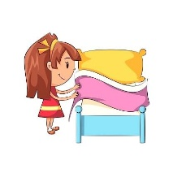 make my bed
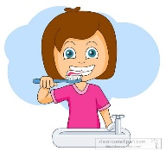 brush my teeth
have breakfast
go to school
have lunch
watch TV
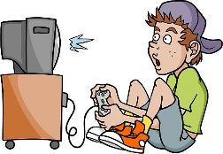 play computer games
have dinner
go to bed

I often wake up at 6 o’clock.
I always go to school at half past 7.
I sometimes play computer games at 5 o’clock.
I never go to bed at half past ten.

always - uvijek
often – često
sometimes – ponekad
never – nikada

- Riješiti zadatak iz u/ 49, zadatak D – pročitati rečenice i staviti kvačicu u koje doba dana radimo koje aktivnosti

